Notices Admin Guide

By Richard Easton

## Overview

This guide is to aid, staff who are responsible in looking after the notices system, and it’s day to day running.

Logging in for the first time

Click the button, and you will be asked to login with the [*username*] and [*password*] provided by the system administrator.

You will now see a new menu item on the navigation bar called **Administration**

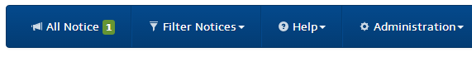

From this menu you will be able to see the following:

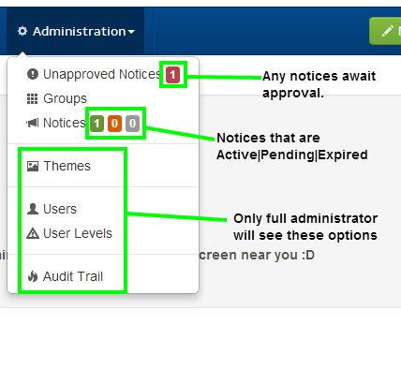

Unapproved Notices

Notices that have been submitted by other member of staff will be held here for approval, this is to stop any unapproved notices appearing on the live pages (s), and will be shown in a table list.

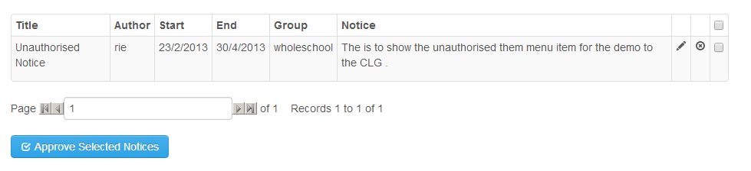

You can approve a notice by ticking the corresponding box at the end of each notice row, (multiple notices can be approved at the same time), and then clicking the “**Approved Selected Notices**” button below the table.

You can also edit a particular notice by clicking the pencil icon of the notice, which will allow you to change the following information

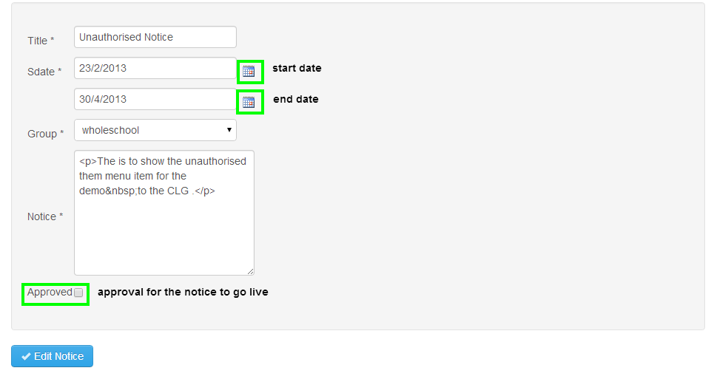

You can also delete an unapproved notice by clicking the  icon, which will completely remove that notice.

Once approved the notice will move from the “**unapproved Notices**” menu entry and appear on the active or pending notice count, if the date is within the start and end dates the notice will appear on the system.

Reinstating an expired notice

If an active notice expires, it can be reinstated by selecting the desired notice and editing the start and end dates accordingly, which will then move the notice back into either the pending or active notice count.

Userlevels, Groups and Users

Userlevels are used to govern what a particular group of users can see, approved or administer on the notices system,

The “Approvers” group will be able to approve notices, edit existing notices, and add new notices.

Administrators will be able to do all of the above, plus add new groups, userlevels, users and edit existing users.

Most of the functions are simple to follow, and your system administrator will provide relevant training should you need it.